E-mail from Christian Nilsen, 6/6/23, titled “Verification data”

Here’s what is available. This shows the number of samples for each parameter/study. I don’t know if we’ll be able to do TKN – I can find any that report TKN or Total N.
What do you think? Should we try to use all 5 of these?

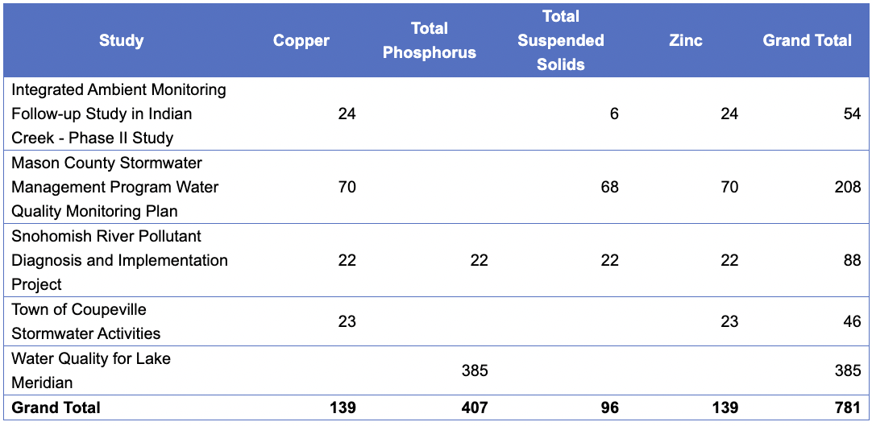

Department of Ecology’s EIM website has data that might work for model validation. Eva met with Christian a week before 6/12/23 and reported back to Sarah on 6/12/23 that Christian was aggregating the EIM data and adding landscape predictor values to it.

2023-06-20 Stand-Up (notes in Jira): There are a set of locations in Olympia that could be used for validation. There are some additional datasets that have limited data - these are welcome (“any amount of data from anywhere”) from Eva. Want to check 50% vs. 95% prediction intervals.
- Christian: The areas that look good are Mason County and Bremerton. We don’t have the contributing catchments to the outfall data points, but we could make our best guess.
- Eva: There is concern about manufacturing that contributes to high levels of stormwater pollutants - we might not have captured this in our model.
- Christian: Naval shipyard is downstream of the outfall sites.
- Eva: Would prefer a few data points across a wide area > lots of data for small areas.
The Mason County results come from EIM @ SWH-172: Christian to share the ECY EIM database with Eva and search through it together for information needed for the water quality model validation.CANCELLED. From there, Christian will make a decision about the Bremerton P&L PDF extraction.

Eva’s Data Search on EIM 2/13/2024:

https://apps.ecology.wa.gov/eim/search/Default.aspx

County Name is in Jefferson or King or Kitsap or Pierce or San Juan or Skagit or Snohomish or Whatcom or Thurston or Mason or Island or Clallam
Location Setting is in Source-ManMade
Sample Source is Stormwater Catch Basin or Stormwater outfall or Stormwater sheetflow
Result Parameter or its alias is in Copper or Total Suspended Solids or Zinc or Total Phosphorus or Total Kjeldahl Nitrogen as N

Eva’s questions for Christian:

- What types of samples are appropriate:
  - Stormwater catch basins?
  - Manholes?
  - Stormwater outfalls?
- If the samples are flowing out to a water source (e.g., Puget Sound), how do we know which section of land surface is flowing out to that location?
- If a study was completed for the purpose of toxics clean-up, does that study automatically not fit our model validation data requirements?

We should only be interested in stormwater outfall data. Catch basin data is usually sediment data, not water data. Sheet flow doesn’t represent what we’re looking for. It’s a small area, and data is going to be different. Manholes = depends on whether they’re water samples or sediment. Most catch basins will be sediment, unless its specific study around … can keep it in there. In EIM there’s a filter for matrix: should be water.
Outfalls – end point of a storm drain network. Will have point that’s an outfall and watershed or catchment are that is associated with it. Christian will provide landscape predictors for the watershed that is being drained. For each watershed, have catchment area that drains to that watershed. Those are either available from agencies, or Jamie digitized from QAPP. That was for 14 that we used; Christian would do the same thing for model validation datasets.
Black corrugated pipes coming out of hillside? Could take a look. Will need to read the study to see.
Toxics cleanup – doesn’t fit. Biases data toward a very polluted site. We’re looking for ambient conditions that we can make predictions across Puget Sound. Toxic sites are going to be outliers. Christian would tend to stay away, as we’re looking at municipal outfall data and most of those sites are going to be industrial locations. We are making predicitons of industrial landuses, but our data Is really for municipal outfall data. Eva thinks maybe if we have a comparison between toxic and nontoxic in similar situation? Maybe if we use sampling data that is NOT that pollutant that its being cleaned up for. Usually toxic site – history of site – dumping/ action that result in it being toxic. We don’t have a predictor of leaking UST or anything.

From King Co QAPP for S8 Data Collection:
Flow-weighted composite samples are collected from the entire duration of a storm and are proportional to the stormwater flow at the sampling site (i.e. if the stormwater volume increases then the amount of sample collected increases proportionally).

Hierarchy of Studies to Use
Feb 27, 2024

- Studies with more than 1 constituent of interest, more than one location, and we’re pretty sure it fits well with our study:
  - Town of Coupeville G0900060
    - Copper, Zinc
    - 5 locations
  - Tacoma S8C WAR044003_S8C
    - Up to 7 outfalls
    - Copper, total phosphorus, TSS, zinc, Total Nitrogen, mixed forms as N
  - Caldart Ave Poulsbo G0700270
    - 3 inlets to bioswales
    - TSS, phosphorus, Nitrogen
  - White Center G0900041
    - 5 outfalls that may work
    - TSS, phosphorus
  - Lower White River GPEL0010
    - TSS, phosphorus
    - 3 outfall locations
- Studies with only 1 constituent of interest, but more than one location/ sampling date:
  - Lake WA PFAS Survey SWON0003
    - TSS
    - 85 total locations, some of which are outfalls
  - Lake Meridian LkMeridian_WQ
    - Total Phosphorus
    - 5 locations
- Studies with only 1-2 locations, 1-2 constituents of interest and/or 1-2 sampling dates:
  - Lahti Drive G1100234
    - 1 location
    - TSS, phosphorus
  - Indian Creek BERA0010
    - TSS, copper, zinc
    - 2 locations
    - Not entirely sure if the locations are culverts or outfalls… it’s unclear
  - Watershed Friendly Gardening Ed Program G0500170
    - TSS, Total Phosphorus
    - 2 locations
    - Catch basins; are they flow-weighted? Couldn’t tell from QAPP
  - Henderson Inlet DSAR2
    - Total Phosphorus
    - 1 location
- Studies where we’re not sure how well it fits with our study:
  - Mason County G0800631
    - Copper, zinc, TSS
    - 1-8 locations
    - If outfalls are draining the Bremerton ship yard, don’t use them! That is one of most polluted ship yards in the region!
  - Lower Duwamish LDWISS
    - 2 outfall locations
    - Copper, TSS, zinc
    - Sample source: stormwater in-line (might make this unsuitable for our study); Per the Sampling Tech Memo, samples are grab samples (NOT flow-weighted)

Nitrogen vs TKN:
https://www.velp.com/en-us/exploring-the-differences-between-total-kjeldahl-nitrogen-tkn-and-total-nitrogen-tn.aspx

TKN vs TN

Kjeldahl’s method gives reliable results if the sought value is the sum of organic nitrogen (proteins, nucleic acids, urea, synthetic organic chemicals) and ammonia nitrogen while other nitrogen compounds are not present.
For the determination of total nitrogen in samples when the most relevant substances are ammonium, organic nitrogen, nitrate and nitrite, depending on the standard and the purpose of the determination, an elemental analyzer is needed.
Therefore, depending on the type of sample, the purpose of the analysis and the different substances, the following values are analyzed:

- TKN (Total Kjeldahl Nitrogen) = Total organic nitrogen + ammonium
- Total organic nitrogen = TKN - ammonium
- Total inorganic nitrogen = (nitrate + nitrite) + ammonium
- TN (Total Nitrogen) = TKN + Nitrate + Nitrite

USGS – Persulfate digestion and comparison to TKN and TKP
https://pubs.usgs.gov/publication/wri034174

Alkaline persulfate digestion was evaluated and validated as a more sensitive, accurate, and less toxic alternative to Kjeldahl digestion for routine determination of nitrogen and phosphorus in surface- and ground-water samples in a large-scale and geographically diverse study conducted by U.S. Geological Survey (USGS) between October 1, 2001, and September 30, 2002. Data for this study were obtained from about 2,100 surface- and ground-water samples that were analyzed for Kjeldahl nitrogen and Kjeldahl phosphorus in the course of routine operations at the USGS National Water Quality Laboratory (NWQL). These samples were analyzed independently for total nitrogen and total phosphorus using an alkaline persulfate digestion method developed by the NWQL Methods Research and Development Program. About half of these samples were collected during nominally high-flow (April-June) conditions and the other half were collected during nominally low-flow (August-September) conditions. The number of filtered and whole-water samples analyzed from each flow regime was about equal. By operational definition, Kjeldahl nitrogen (ammonium + organic nitrogen) and alkaline persulfate digestion total nitrogen (ammonium + nitrite + nitrate + organic nitrogen) are not equivalent. It was necessary, therefore, to reconcile this operational difference by subtracting nitrate + nitrite concentrations from alkaline persulfate dissolved and total nitrogen concentrations prior to graphical and statistical comparisons with dissolved and total Kjeldahl nitrogen concentrations. On the basis of two-population paired t-test statistics, the means of all nitrate-corrected alkaline persulfate nitrogen and Kjeldahl nitrogen concentrations (2,066 paired results) were significantly different from zero at the p = 0.05 level. Statistically, the means of Kjeldahl nitrogen concentrations were greater than those of nitrate-corrected alkaline persulfate nitrogen concentrations. Experimental evidence strongly suggests, however, that this apparent low bias resulted from nitrate interference in the Kjeldahl digestion method rather than low nitrogen recovery by the alkaline persulfate digestion method. Typically, differences between means of Kjeldahl nitrogen and nitrate-corrected alkaline persulfate nitrogen in low-nitrate concentration (< 0.1 milligram nitrate nitrogen per liter) subsets of filtered surface- and ground-water samples were statistically equivalent to zero at the p =level.Paired analytical results for dissolved and total phosphorus in Kjeldahl and alkaline persulfate digests were directly comparable because both digestion methods convert all forms of phosphorus in water samples to orthophosphate. On the basis of two-population paired t-test statistics, the means of all Kjeldahl phosphorus and alkaline persulfate phosphorus concentrations (2,093 paired results) were not significantly different from zero at the p = 0.05 level. For some subsets of these data, which were grouped according to water type and flow conditions at the time of sample collection, differences between means of Kjeldahl phosphorus and alkaline persulfate phosphorus concentrations were not equivalent to zero at the p = 0.05 level. Differences between means of these subsets, however, were less than the method detection limit for phosphorus (0.007 milligram phosphorus per liter) by the alkaline persulfate digestion method, and were therefore analytically insignificant.This report provides details of the alkaline persulfate digestion procedure, interference studies, recovery of various nitrogen- and phosphorus-containing compounds, and other analytical figures of merit. The automated air-segmented continuous flow methods developed to determine nitrate and orthophosphate in the alkaline persulfate digests also are described. About 125 microliters of digested sample are required to determine nitrogen and phosphorus in parallel at a rate of about 100 samples per hour with less than 1-percent sample in

Nitrogen & Phosphorus Calculations
https://echo.epa.gov/trends/loading-tool/resources/nutrient-aggregation
Nutrient aggregation approximates a Total Nitrogen and Total Phosphorus load by combining loads for various nitrogen and phosphorus species. Total nitrogen consists of organic nitrogen, ammonia, nitrate, and nitrite; or total Kjeldahl nitrogen (TKN), nitrate, and nitrite. Typically, organic nitrogen and TKN account for the majority of the total nitrogen load. As a result, if a facility is not required to report total nitrogen, TKN, or organic nitrogen; the loadings tool calculation will underestimate the aggregated nitrogen load. Phosphorus compounds may be reported as phosphorus or phosphate in ICIS-NPDES.
For nitrogen and phosphorus parameters, the Loading Tool calculates an aggregate nitrogen load and aggregate phosphorus load for each outfall and monitoring location at each facility using the following logic:
- For Total Nitrogen (as N):
  - If Total Nitrogen is reported, use that load for total nitrogen;
  - If Total Nitrogen is not reported and TKN is > 0, then Total Nitrogen = TKN + Nitrate + Nitrite;
  - If TKN is not reported and Organic Nitrogen is > 0, then Total Nitrogen = Organic Nitrogen + Ammonia + Nitrate + Nitrite; and
  - If Organic Nitrogen is not reported, then Total Nitrogen = Ammonia + Nitrate + Nitrite
- For Total Phosphorus (as P):
  - If Total Phosphorus is reported, then use that load for total phosphorus; and
  - If Total Phosphorus is not reported, then use the Phosphate load and convert to phosphorus

Table 3-10. Priorities for Nitrogen Aggregation
Parameter Code | Parameter Description | Conversion Factor | Calculation Parameter | Parameter Selection Priority
Equation 1: Total Nitrogen = TOTAL N
00600 | Nitrogen, total (as N) | 1 | TOTAL N | 1
51445 | Nitrogen, Total | 1 | TOTAL N | 2
51084 | Nitrogen, total available (water) | 1 | TOTAL N | 3
Equation 2: Total Nitrogen = TKN + NITRATE + NITRITE
00625 | Nitrogen, Kjeldahl, total (as N) | 1 | TKN | 1
51449 | Nitrogen, Kjeldahl Total | 1 | TKN | 2
51087 | Nitrogen, Kjeldahl, total (TKN) (water) | 1 | TKN | 3
82539 | Nitrogen, Kjeldahl | 1 | TKN | 4
49579 | Nitrogen, total Kjeldahl | 1 | TKN | 5
81639 | Nitrogen Kjeldahl, total (TKN) | 1 | TKN | 6
00623 | Nitrogen, Kjeldahl, dissolved (as N) | 1 | TKN | 7
00620 | NITROGEN, NITRATE TOTAL (AS N) | 1 | NITRATE | 1
71850 | Nitrogen, nitrate total (as NO3) | 0.225806452 | NITRATE | 2
51100 | Nitrogen, total, as NO3, (water) | 0.225806452 | NITRATE | 3
51086 | Nitrogen, nitrate (NO3), (water) | 0.225806452 | NITRATE | 4
00615 | Nitrogen, nitrite total (as N) | 1 | NITRITE | 1
51447 | Nitrogen, Nitrite Total | 1 | NITRITE | 2
00613 | Nitrite, nitrogen, dissolved (as N) | 1 | NITRITE | 3
71855 | NITROGEN, NITRITE TOTAL (AS NO2) | 0.304347826 | NITRITE | 4
Equation 3: Total Nitrogen = ORG N + AMMON + NITRATE + NITRITE
00605 | Nitrogen, organic total (as N) | 1 | ORG N | 1
00607 | Nitrogen, organic, dissolved (as N) | 1 | ORG N | 2
00610 | Nitrogen, ammonia total(as N) | 1 | AMMON | 1
51446 | Nitrogen, Ammonia Total | 1 | AMMON | 2
00609 | Ammonia, nitrogen, total, (as N) 30 day | 1 | AMMON | 3
00612 | Nitrogen, ammonia, tot unionized (as N) | 1 | AMMON | 4
34726 | Nitrogen, ammonia, total (as NH3) | 0.823529412 | AMMON | 5
51085 | Nitrogen, ammonia, (NH3-N)(water) | 0.823529412 | AMMON | 6
61574 | Ammonia (as N) + unionized ammonia | 0.823529412 | AMMON | 7
00619 | Ammonia, unionized | 0.823529412 | AMMON | 8
00608 | Nitrogen, ammonia dissolved | 0.823529412 | AMMON | 9
82230 | Total Ammonia & Ammonium | 0.823529415 | AMMON | 10
71845 | Nitrogen, Ammonia Total (as NH4) | 0.823529415 | AMMON | 11
00620 | NITROGEN, NITRATE TOTAL (AS N) | 1 | NITRATE | 1
71850 | Nitrogen, nitrate total (as NO3) | 0.225806452 | NITRATE | 2
51100 | Nitrogen, total, as NO3, (water) | 0.225806452 | NITRATE | 3
51086 | Nitrogen, nitrate (NO3), (water) | 0.225806452 | NITRATE | 4
00615 | Nitrogen, nitrite total (as N) | 1 | NITRITE | 1
51447 | Nitrogen, Nitrite Total | 1 | NITRITE | 2
00613 | Nitrite nitrogen, dissolved (as N) | 1 | NITRITE | 3
71855 | NITROGEN, NITRITE TOTAL (AS NO2) | 0.304347826 | NITRITE | 4
Equation 4: Total Nitrogen = AMMON + NITRATE + NITRITE
00610 | Nitrogen, ammonia total (as N) | 1 | AMMON | 1
51446 | Nitrogen, Ammonia Total | 1 | AMMON | 2
00609 | Ammonia nitrogen, total, (as N) 30 day | 1 | AMMON | 3
00612 | Nitrogen, ammonia tot unionized (as N) | 1 | AMMON | 4
34726 | Nitrogen, ammonia total (as NH3) | 0.823529412 | AMMON | 5
51085 | Nitrogen, ammonia (NH3-N), (water) | 0.823529412 | AMMON | 6
61574 | Ammonia (as N) + unionized ammonia | 0.823529412 | AMMON | 7
00619 | Ammonia, unionized | 0.823529412 | AMMON | 8
00608 | Nitrogen, ammonia dissolved | 0.823529412 | AMMON | 9
82230 | Total Ammonia & Ammonium | 0.776409915 | AMMON | 10
71845 | Nitrogen, Ammonia Total (as NH4) | 0.776409915 | AMMON | 11
00620 | NITROGEN, NITRATE TOTAL (AS N) | 1 | NITRATE | 1
71850 | Nitrogen, nitrate total (as NO3) | 0.225806452 | NITRATE | 2
51100 | Nitrogen, total, as NO3, (water) | 0.225806452 | NITRATE | 3
51086 | Nitrogen, nitrate (NO3), (water) | 0.225806452 | NITRATE | 4
00615 | Nitrogen, nitrite total (as N) | 1 | NITRITE | 1
51447 | Nitrogen, Nitrite Total | 1 | NITRITE | 2
00613 | Nitrite nitrogen, dissolved (as N) | 1 | NITRITE | 3
71855 | NITROGEN, NITRITE TOTAL (AS NO2) | 0.304347826 | NITRITE | 4

Table 3-11. Priorities for Phosphorus Aggregation
Parameter Code | Parameter Description | Conversion Factor | Calculation Parameter | Parameter Selection Priority
Equation 1: Total Phosphorus = Phosphorus (PHOSP)
00665 | Phosphorus, total (as P) | 1 | PHOSP | 1
51451 | Phosphorus, Total | 1 | PHOSP | 2
70507 | Phosphorus, in total orthophosphate | 1 | PHOSP | 3
00670 | Phosphorus, total organic (as P) | 1 | PHOSP | 4
00662 | Phosphorus, total recoverable | 1 | PHOSP | 5
00666 | Phosphorus, dissolved | 1 | PHOSP | 6
Equation 2: Total Phosphorus = Phosphate (PO4)
00650 | Phosphate, total (as PO4) | 0.326315789 | PO4 | 1
00660 | Phosphate, ortho (as PO4) | 0.326315789 | PO4 | 2
00655 | Phosphate, poly(as PO4) | 0.326315789 | PO4 | 3
71888 | Phosphate, total soluble (as PO4) | 0.326315789 | PO4 | 4
70505 | Phosphate, total, color method (as P) | 0.326315789 | PO4 | 5

Study ID: G0900060
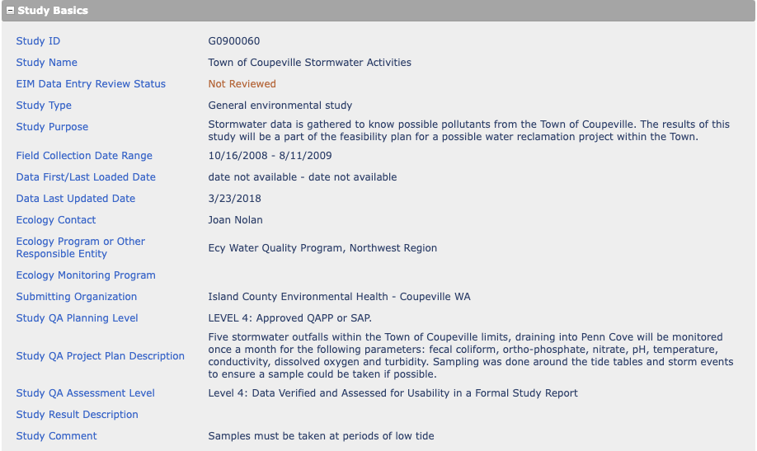
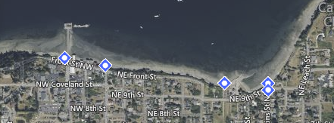
Has data for Copper & Zinc; all points are outfalls just before they enter Puget Sound. How would we choose the contributing region for these outfalls?
Christian identified as useful. I have downloaded data.
YES!
Potentially useful locations:
- Coupeville wharf – large outfall directed north of the wharf
- Front and Main – outfall located just north of Kneed and Feed on the beach
- Boat Launch – outfall located directly east of wastewater system, near boat launch
- Perkins and 9th – sample from catch basin grate at the intersection
- Perkins Bluff – sample taken from cut in the pipe on the bluff at Perkins, or from outfall
Study ID: WAR044003_S8C
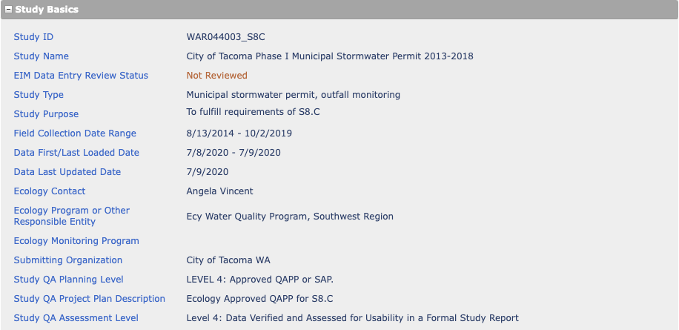
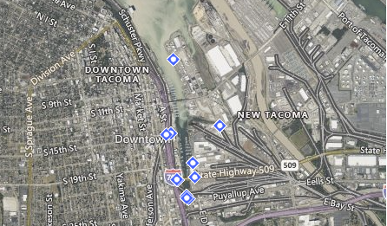
City of Tacoma S8 follow-on sampling, from 2013-2018.
I have downloaded data.
THIS IS GOOD DATA> Christian used it to verify our predictiosn for Tacoma project. Would be nice to have one from an agency that is not included in our S8 data. If this is different locations, could be fun. Two other catchments that are not include in S8A data.

Possible locations of interest:
- OF237A_New – dock st pump station yard. West twin 96er STW sampling site in manhole vault SWMH102807 (sample source: stormwater in-line)
- OF254 – east F St and East 15th st; STW sampling location OF254 in stormwater line downstream of Manhole SWMH105053 northeast of the intersection (sample source: stormwater in-line)
- OF243_FD23 – east 21st st and D street; STW sampling location OF243 in stormwater line upstream of SWMH106461 in sidewalk on west side of D street under SR 509 (sample source: stormwater in-line)
- OF245_MH390 – STW sampling location OF245 in stormwater line downstream of manhole SWMH106463, at Johnny’s Restaurant in parking stall (sample source: stormwater in-line)
- OF235 --- East 21st and Dock st; STW sampling location OF235 in stormwater line stream of manhole ___ on parking lot under SR509 (sample source: stormwater in-line)
- OF237B_FD1 (similar to above concept)
- OF230 (similar to above in concept)

Study ID: G0700270
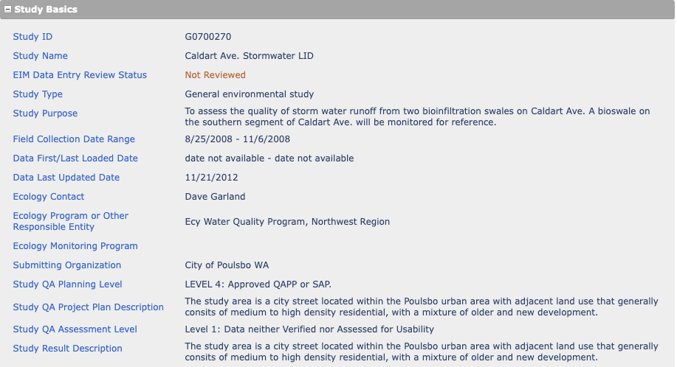
Located in Poulsbo. Samples are from bioswales, to test whether they are effective.
Kinda like a canal/ ditch? Would be interested in what the influent to a bioswale would be. If it’s a large catchment similar to an outfall, can look at influent data.
Inlet locations are:
- S1I – inlet – tested for TSS, phosphorus, nitrogen
- S2I – same as above
- S3I – same as above
I downloaded data.

Study ID: G0900041
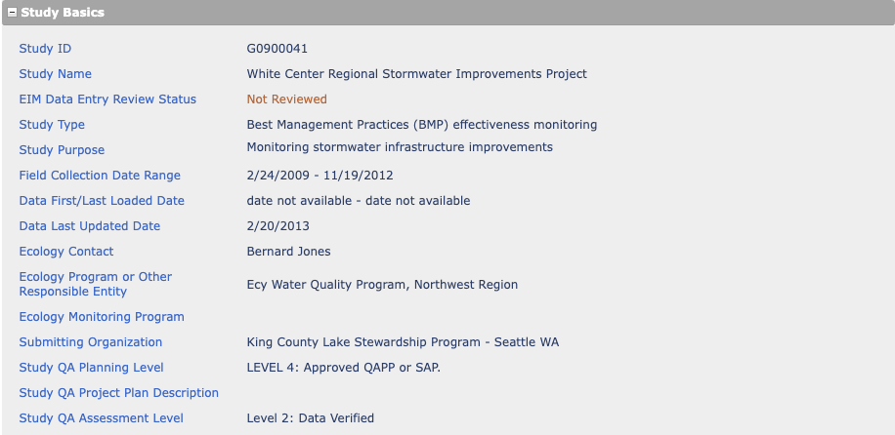
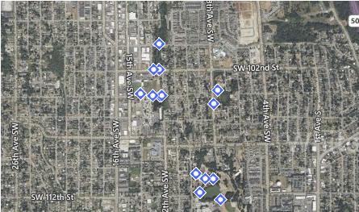
Study in White Center. Some samples collected from wetlands/ bioswales, others from manholes and outflow locations. It’s worth investigating these locations further before feeling confident with the study
Manholes COULD be flow-weighted samples. If so, ok. Inflow ones would be ones to look at. Some might be promising. Tested for Phosphorus and TSS
Locations that might work:
- Outflow/Parking_Wetland – outflow from N end of parking lot to wetland feeding the detention pond (Stormwater BMP influent)
- Outflow_to_MallardLk – outflow flowing to Mallard Lake from the northwest (Stormwater BMP influent)
- Inflow_Stormcell1_N.Side – inflow to storm cell 1 on north side of SW 100th by caged manhole (stormwater BMP influent)
- Outflow/From_N.To_MallardLk – outflow from north (storm cells 1,2,3) at entrance to Mallard Lake (stormwater BMP influent)
- Outflow/Ballfields_to_Lake – outflow from ballfields and high schools to Lake hicks from the South (Stormwater BMP influent)
Study ID: BERA0010
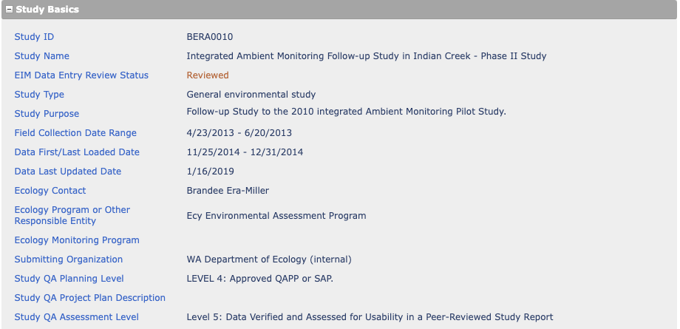
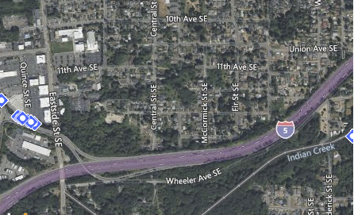
Two storm drains are sampled in this study that Christian identified.
I have downloaded data. Copper, TSS, zinc
Two locations include:
- PLUM STW: plum street stormwater culvert – sample source=stormwater outfall
- QUINCE STW: stormwater culvert – sample source=groundwater, stormwater outfall (based on the QAPP, the stormwater outfall is different than the groundwater samples)

From the QAPP posted online at:
https://apps.ecology.wa.gov/publications/documents/1303110.pdf
NOTE: there is no mention of flow-weighted samples; I’m wondering if these data are useful? Ask Christian!

Stormwater (pg 20)
Stormwater will be sampled directly from 2 stormwater runoff pipes near the lower Indian Creek monitoring site once during the project. The goal will be to catch a storm after at least a 4-day antecedent dry period during April or May, while the trout are instream.

Source ID: SWON0003
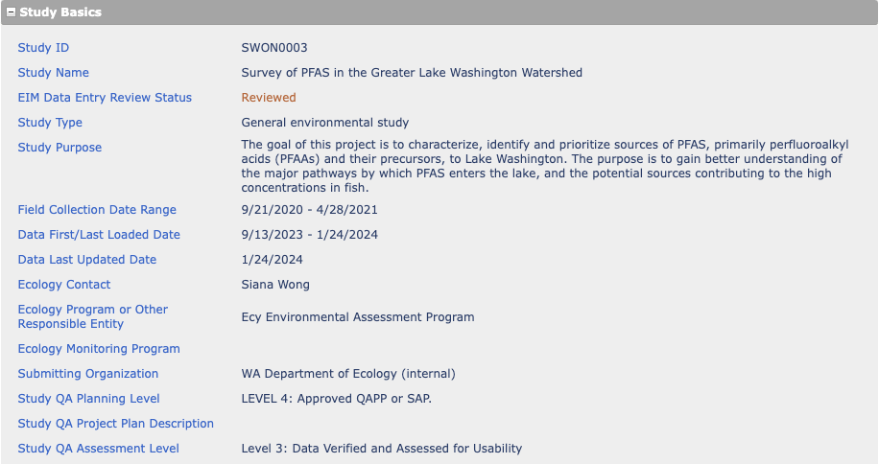
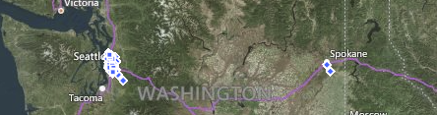
Includes stormwater catchment basins and stormwater outfalls (85 locations total, only some are catchment basins & outfalls). TSS is the only constituent of interest to us
THIS WOULD BE GREAT if OUTFALLS
It IS outfalls! I downloaded data.

NOTE: the QAPP says that the samples are time-weighted! Christian says that time-weighted samples, in practicality, are very similar to flow-weighted samples. In flow-weighting, you have to anticipate the duration and pattern of the storm and take samples appropriately. The methodology is prone to error. In time-weighted, you will likely be biasing for early/ late parts of the storm, but the samples are more similar to flow-weighted than to grab samples.

QAPP: https://apps.ecology.wa.gov/publications/documents/2003112.pdf
Addendum 1: https://apps.ecology.wa.gov/publications/documents/2103105.pdf
Addendum 2: https://apps.ecology.wa.gov/publications/documents/2203114.pdf

Source ID: GPEL0010
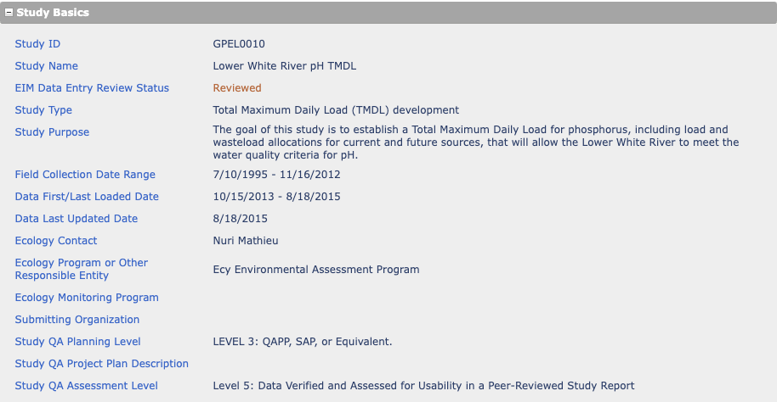
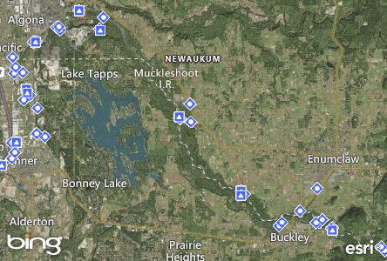
3 stormwater outfall/culvert locations (tested for phosphorus & TSS):
- 10-UNW-SW0.9 -- Stormwater outfall/culvert on bank of river
- 10-UNW-SW3.3 -- Stormwater outfall/culvert on bank of river
- 10-UNW-SW6.2 -- City of Auburn pump station discharge channel on bank of river
STORMWATER OUTFALL on bank of river (as long as its stormwater data) would be good. Areas that are done for TMDL’s are already listed for a pollutant. So—don’t think its going to be as concerning as some of toxic cleanup sites, this is a pH tmdl. If we’re looking at TSS, its probably. CHRISTIAN OK WITH THIS ONE

Study ID: LKMeridian_WQ
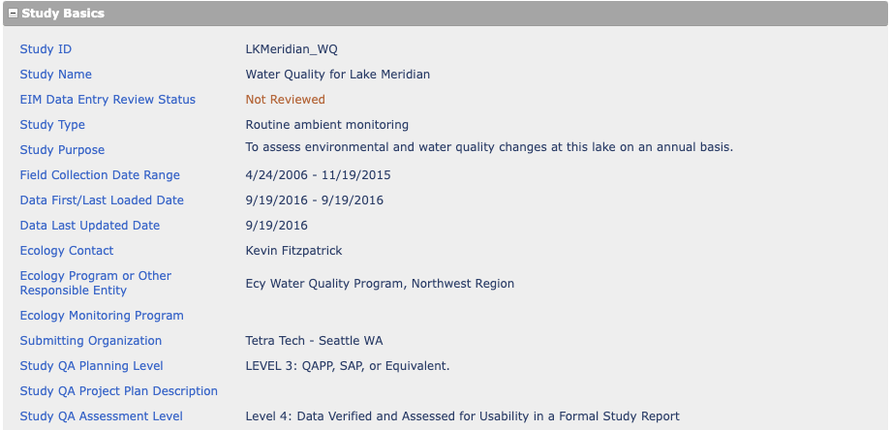
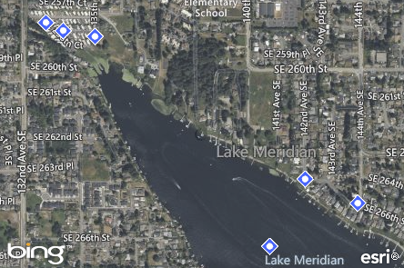
Five outfalls: two from pipes (12” and 36”) and three other outfalls. Studies include Total Phosphorus
I have downloaded data; Christian recommended this study
OK! Christian comfortable with pipes and with other outfalls
5 outfalls/ pipes:
- MER_S1 – outfall
- MER_S2 – outfall
- MER_S3 – 12” pipe
- MER_S4 – 36” pipe
- MER_S5 – outfall

Study ID: G1100234
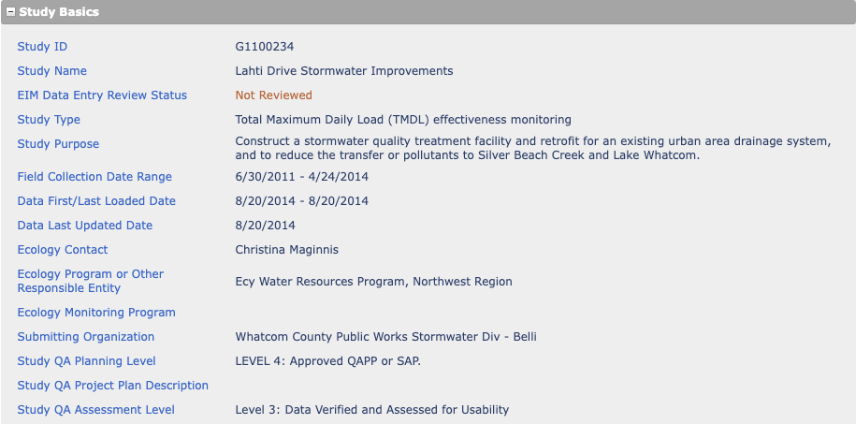
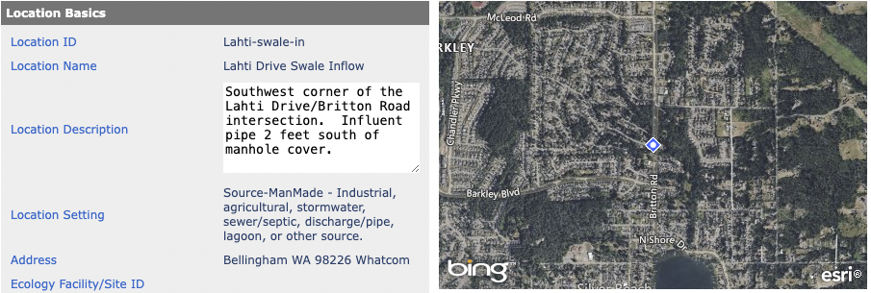Another instance of swale monitoring in Whatcom county. Tested for TSS & Phosphorus at 2 locations.
No on swales. Influent data for swale might be useful, but swale itself is not.
I have downloaded data.
Find out if the influent data (1 swale) is from flow-weighted samples!

Source ID: G0500170
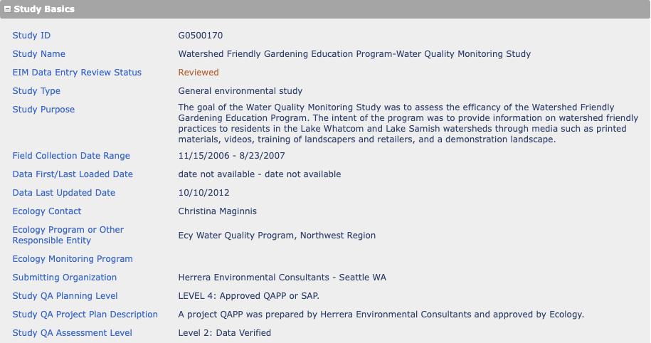
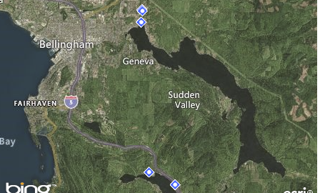
I downloaded data. Constituents: TSS, Total Phosphorus
Two locations that are man-made:
- Woodlake Road 1: catch basin (sample source: fresh/surface water, stormwater)
- Woodlake Road 2: catch basin (sample source: stormwater)

If these are catch basins and the samples are stormwater, are they automatically not flow-weighted? Prob need to LOOK AT QAPP
Study ID: DSAR2
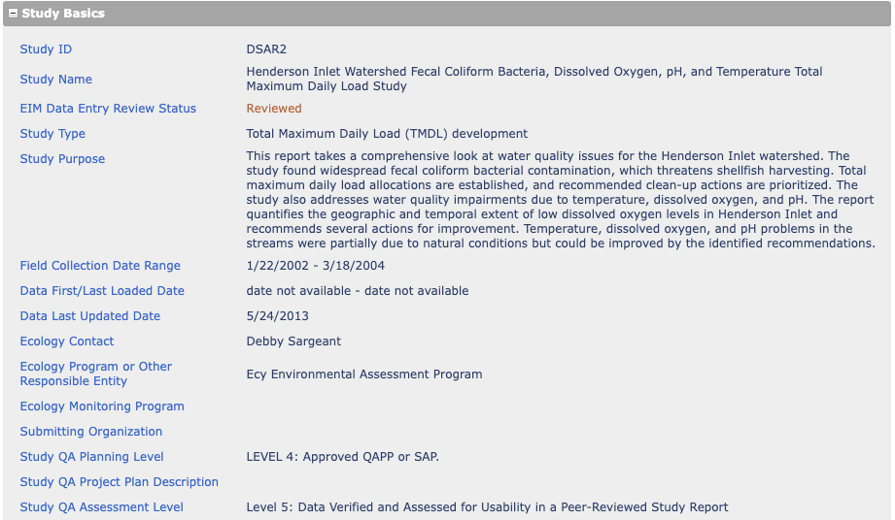
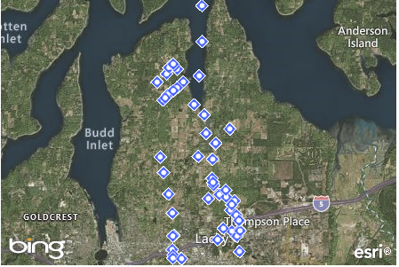
Includes 1 suitable outfalls. Sampled for phosphorus
- WL2.6SW – stormwater outfall pipe entering woodland creek

QAPP found at: https://apps.ecology.wa.gov/publications/documents/0603012.pdf
NOTE: hmmm… there isn’t any wording about how the one outfall was sampled. The study focuses most on fecal coliform bacteria. Without further info, we might hesitate to use this study (it is also only tested for phosphorus)

Study ID: G0800631
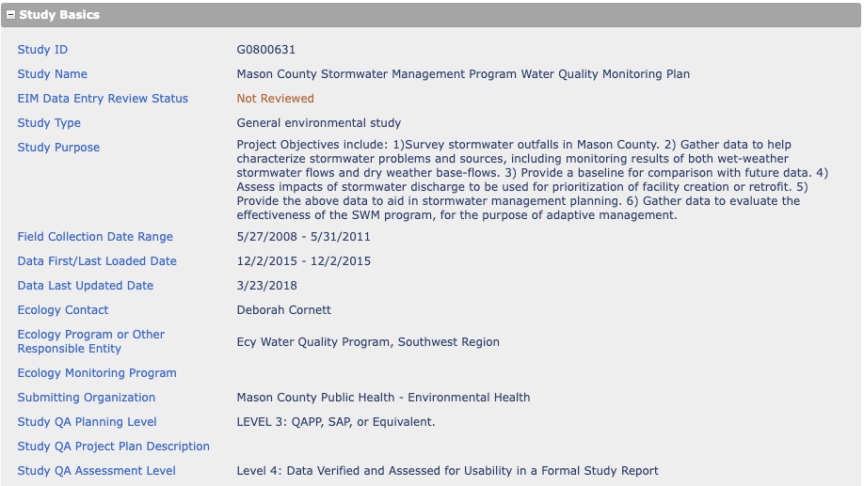
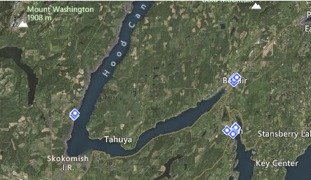
This study was identified by Christian as a suitable one. I have downloaded data
YES – this one was a little tricky b/c a lot of the sites are going to be in Bremerton shipyard. Shipyards?? Part of Seattle area, but not really characterized in our study. Pull QAPP, look at the catchment areas that are draining into each of these. If it is draining a shipyard, not so good. Find land covers that are similar to the ones that are in our dataset. Are we doing a dis-service to our map if we only look at data similar to what we have? Bremerton ship yard will be one of most polluted sites. They scrape copper-containing paint off of their boats there. Will be dirty.
Locations that could be suitable:
- Mason_Belfair_BF-034 – outfall
- Mason_Belfair_BF-035 – mouth of 18” ditch culvert (??)
- Mason_Hoodsport_HS-033 – storm grate in middle of Fish & Wildlife parking lot, draining from North Hill
- Mason_North_Bay_NB-001 – exiting from 24” concrete culvert between blue & maroon house
- Mason_North_Bay_NB-014 – corner of Lakeland Dr. and Wheelwright
- Mason_North_Bay_NB-018 – Lake Land Village Golf Course Bistro – storm grate just north of Bistro driveway entrance. On fairway. Sample nutrients only
- Mason_North_Bay_NB-019 – Lennard K, storm grate in southeast corner o parking lot (NB-03 is culvert exiting on beach)
- Mason_North_Bay_NB-020 – Storm grate above southernmost major drainage to beach in Allyn (NB-01 is culvert on beach)

Study ID: LDWISS
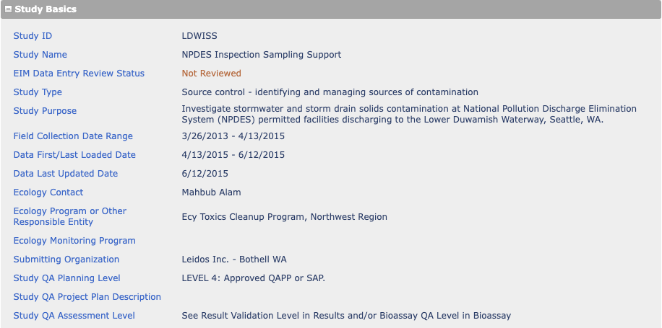
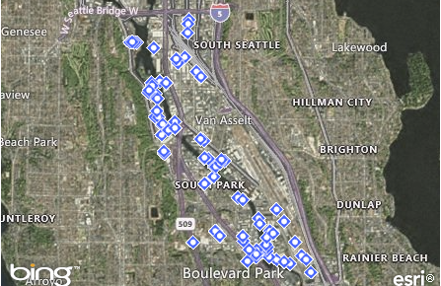
Toxics cleanup program sampling; Investigating contamination in stormwater outfalls (also in-line and BMP effluent). Lots of manholes and catch basins and outfalls along the Duwamish R
Might be some in there that we could use. Want to make sure that these are not combined sewer systems. Sewer overflow into stormwater system is a problem! Trigger words to look for: Storwmater outfall or combined sewer outfall. If we don’t know, can look at combined sewer map, shows which are separate/ which are combined.
Two outfall locations that may be suitable (might be more – will need to request QAPP):
- Outfall OF006 – located on the river bank SE of Northland Services facility (source: stormwater in-line)
- Outfall OF002 – (same as above)
Does the stormwater in-line make these unsuitable?
I downloaded data. Copper, TSS, zinc
NOTE: from the Inspection Sampling Support Tech Memo, the water samples were grab samples: “To collect the water sample from a confined space, a decontaminated, stainless steel 5-gallon container was attached to a telescoping pole and lowered into the stormwater structure. In some instances, the water sample was collected directly from an outfall or treatment system sampling port. Water collected was composited in a decontaminated, stainless steel bucket. A decontaminated, stainless steel pitcher was used to transfer water from the stainless steel bucket to pre-labeled sample bottles.” (pg. 3)

